- How many bonds must carbon always have?
- What type of bonding occurs in alkanes?
- Are alkanes saturated or unsaturated?
- What is the difference between conformational isomers and structural isomers?

Ex. C₅H₁₂

- Molecular formula for: alkane cycloalkane

- Give the molecular formula for the following molecules. Then, state the name.
- 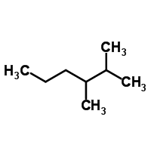 b. 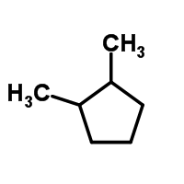

- Which of the following molecules has the molecular formula C₅H₁₀?
- 2-methylpentane
- cyclopentane
- 1-methylcyclobutane
- Pentane

- Draw both the line formula and condensed structural formula for a linear alkane with 7 carbons.

- Draw and name isomers for alkanes with the formula C₆H₁₄.

- Fill in the chart with the corresponding prefix to number of carbons.
Prefix | # of carbons
eth
 | 10
Hept
 | 6
 | 4
meth
prop
Non | 5  8

- What is the isopropyl group? Draw an example of it.

- Name each of the following molecules.
  - 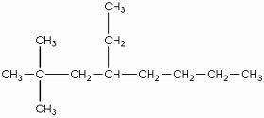 b. 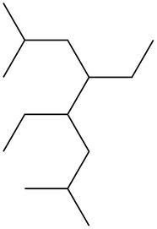

- Draw each of the following molecules.
  - 1-ethyl-2,3,5-trimethylcycloheptane

  - 2-ethyl-5-methyl-4-propyldecane

- Draw and name isomers for C₇H₁₆.

