- Name and give the symbol for the 4 substituents that are halogens.
  - ________________ c. ________________
  - ________________ d. ________________
- In the following molecule, classify the specified carbon as either primary, secondary, tertiary, or quaternary:
3-ethyl-3,4,5-trimethylnonane
Carbon 2________ carbon 3________ carbon 5_______
- Which of the following molecules only contains secondary carbons?
  - 3-methylhexane c. cyclohexane
  - Hexane d. 1,3-dimethylcyclopentane
- Fill in the blanks that are needed to make the following haloalkane:
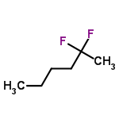
- Alkane melting points and boiling points are said to be ____________ (high/low).
- Which has the higher boiling point: butane or decane? Why?

- Which has the higher boiling point: cyclohexane or hexane? Why?

- Draw and name any six isomers of C₇H₁₄F₂.

