- Alkenes and alkynes are __________________ (saturated / unsaturated). Why?

- What is the geometry about the carbons in the double bond of alkenes? Why?

- Draw the difference between cis and trans isomers. (try 2-hexene). Is this a form of structural or conformational isomers?

Nomenclature
- Draw each of the following molecules and give the molecular formula:
- trans-3-methyl-3-heptene

- cis-2,2-dimethyl-4-nonene

- Name each of the following molecules and give the molecular formula:
  - 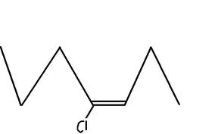 b. 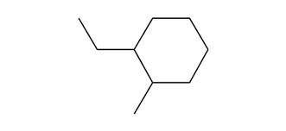
______________________ __________________________
Reactions
- The following reactions all start from the same molecule, 2-butene. 1) Draw this molecule, then 2) preform the following reactions on it

  - Hydrogenation-

____________________ + H₂ ____________________
  - Halogenation-

____________________ + Cl₂ ___________________
  - Hydrohalogenation –

__________________ + HCl ____________________

- Draw and name isomers for C₅H₁₀

