- Define polymerization reaction and then complete the following polymerization reactions:
  - Polymerization reaction-

  - Propylene: CH₂=CHCH₃

  - Chloroethene: CH₂=CHCl

  - Tetrafluoroethene: CF₂=CF₂

- Write the formulas for alcohols and ethers:
  - alcohol R-formula __________ c. ether R formula ____________
  - alcohol molecular formula _________ d. ether molecular formula ________

- Name each of the following alcohols, give the molecular formula, and state whether the alcohol is primary, secondary, or tertiary.
  - 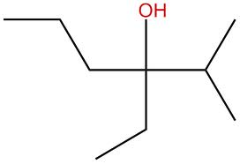 _____________________________
  - CH₃CH₂CH(OH)CH₂CH(CH₃)CH₃ _____________________________
  - CH₃CH₂CH=CHCH₂CH₂OH _____________________________

- Draw each of the following alcohols or ethers.
  - 2-ethyl-3-heptanol
  - 1,5-pentanediol
  - Methyl pentyl ether
  - 2-propoxyhexane

- Complete the following reactions:
  - 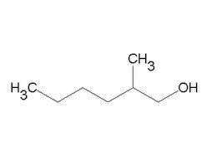 ___________________________ + _____________
H⁺

180 C
H⁺

180 C
  - CH₃CH(OH)CH₂CH₃ ___________________________ +_____________

H⁺

40 ºC
  - 2 CH₃CH₂OH ___________________________ + _____________

  - 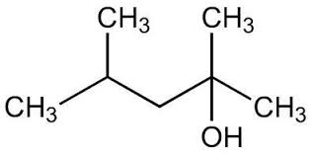 ___________________________ + _____________
H⁺

180 C

