- Write the R formula for carboxylic acids ____________
- Write three acid properties of carboxylic acids.

- Carboxylic acids are strong / weak acids.
- What do β, ϒ, and α refer to for carboxylic acids?

- Name the following carboxylic acids.
  - 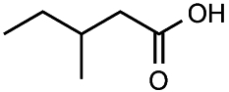 b. 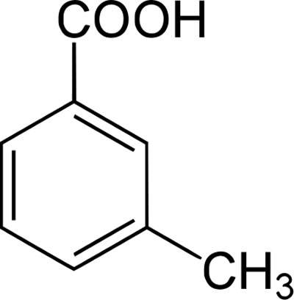
_____________________ ______________________
  - CH₃CH₂CH(CH₃)CH(CH₃)COOH _______________________________
- Draw the following carboxylic acids.
  - Acetic acid _________________________
  - Formic acid _________________________
  - β- hydroxybutanoic acid ___________________________
  - α, ϒ-diethyloctanoic acid ____________________________
- How are carboxylic acids formed? Give an example.
__________________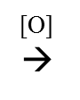___________________________________

- Oxidize propanol.

