- What are the reactants that form 2-methylpentanoic acid? Draw this oxidation reaction.

- Draw the following molecules:
  - 3-ethylheptanoic acid

  - Benzoic acid

  - α,ϒ- dihydroxypentanoic acid

- Describe the overall solubility as well as the solubility trends of carboxylic acids.

- Number the following molecules in terms of highest (1) to lowest (5) in terms of boiling point.
1-pentanol pentanal pentane benzoic acid pentanoic acid
___ ___ ___ ___ ___

- For number 4, tell which ones are water soluble and which ones are less water soluble.

- Show the reaction that forms the carboxylic acid salt sodium pentanoate.

- Write the R formula and molecular formula for an ester. _____________________
- Name the following esters:
  - CH₃CH₂CH₂(CO)OCH₃ ____________________________
  - 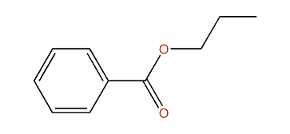 ____________________________
- Complete the following phrase. Then complete the reaction that will create butyl pentanoate.
________________________ + _____________________ Ester + ___________

Review of Carbohydrates- MWF only
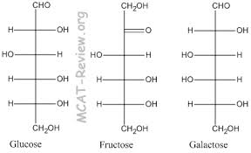
- Put glucose, fructose, and galactose into individual rings. Identify the anomeric carbons, and tell whether it is alpha or beta.

- Link two glucose molecules together to form a disaccharide. Make it have an α-1,4 linkage.

- What is lactase?

- Are lactose free products sweeter or less sweet than those with lactose?

