- Write at least three characteristics of amines that Professor Jablonsky discussed during the lecture. (ex. Hydrogen bonding, geometry, electronegativity etc.)

- For the following amines, (1) classify, (2) give the common name, and (3) give the IUPAC name.
- 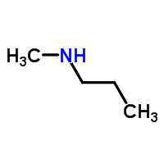
1. _______________________
2. _______________________
3. _______________________

1. _______________________
2. _______________________
3. _______________________
- 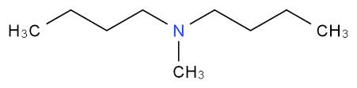

- CH₃CH₂CH₂CH₂CH₂NH₂
1. _______________________
2. _______________________
3. _______________________

- Draw and give the molecular formula for each of the following amines.

- 2-butanamine

- N-ethyl-2-pentanamine

- Pentyl propyl amine

- True / False Amines cannot hydrogen bond to water.
- True / False Primary and secondary amines can hydrogen bond to each other.
- True / False Tertiary amines can hydrogen bond to water.
- True / False Tertiary amines have a higher boiling point than primary and secondary amines.
- React ethyl amine with water. Then answer the following questions.

- What type of ion does the amine form?

- What is the geometry of this ion?

- React ethyl amine with HBr to form an amine salt.

  - Reacting the amine salt with a base reverses this back to the neutral amine (the free base). React the product or number 9 with NaOH to do this.

- Amines are derivatives from ammonium / ammonia.

  - What is the difference between ammonia and ammonium?

  - Draw an example of primary, secondary, tertiary, and quaternary ammonium cations.

