Part 1: Matching and open ended
- Alkaloids
- Amine salts
- Quinine
- Free base
- Pumiliotoxins
- The name of an uncharged amine
- These are amines derived from plants, animals, and fungi
- Decongestants and antihistamines are found as these
- Found in frog skin and arthropod extracts
- The first antimalaria drug/ used to fight fatigue and cold

- Give two properties of alkaloids.

- Describe heterocyclic amines.

- What is the difference between an amine and an amide?

Part 2: Naming and Classification of Amides. A) classify as 1º, 2º, or 3º & B) name the following amides
- 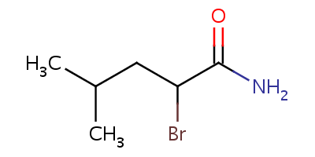
- ___________________
- _____________________________
- 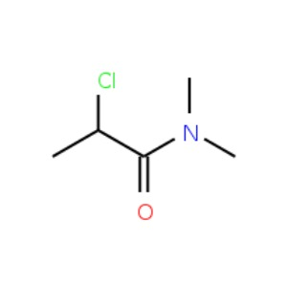
10.

- ___________________
- _____________________________
- ___________________
- _____________________________
- CH₃CH₂CH₂(CO)NHCH₂CH₂CH₃
Part 3: Reactions- Amidation
___________________ + __________________ amide + H₂O

- From amidation:
- primary amine
- Secondary amine
- Tertiary amine
- Ammonia
- Write the reaction for the formation of N-ethyl pentanamide. Draw and name reactants!

- 2-methylbutanoic acid + N,N-dimethylamine

PRACTICE MULTIPLE CHOICE
- When propanoic acid reacts with methyl amine, the reaction called amidation yields _____
  - 2-methyl propanamide
  - N-methyl propyl amide
  - N-propyl methanamide
  - N-methyl propanamide

- What is the name for this compound? CH₃CH₂CH₂NHCH₃ _____
  - Propyl methanamine
  - N-propyl methanamine
  - N-methyl propanamine
  - 2-Butanamine

- Which of the following is NOT an alkaloid? _____
  - Serotonin
  - Ethanamine
  - Caffeine
  - Quinine

- Which of the following cannot form an amide? _____
  - NH₃
  - CH₃(CO)OH
  - (CH₃)₂NH₂
  - (CH₃)₃N

