- What are the groups attached to the same carbon called in an amino acid?

- What is a zwitteron and how do they behave?

- Amino acids link together to form _____________.

- Distinguish between the four classes of amino acids.
Non-polar

Polar

Basic

Acidic

- Identify each of the following as non-polar, polar, basic, or acidic.
- 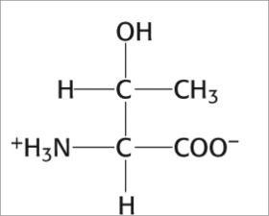 b. 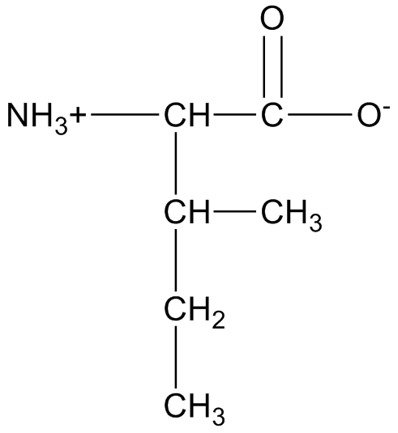 c. 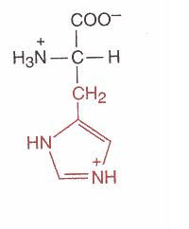d. 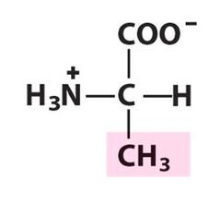

- In nature, the D / L isomer is dominant.

- T / F Met-Pro-Arg will have the same function as Pro-Arg-Met.
- T / F The number of peptide bonds is always the same as the number of residues.
- A peptide bond is a(n) ______________ linkage.
- Write the four categories that peptides can be:

- Follow the steps below in forming a tetrapeptide of threonine, glutamic acid, lysine, and glycine.
  - First, draw each amino separately:

  - Next, combine the four with peptide bonds (remember, this is (C=0)-(NH). Number each residue.

  - Draw arrows to the C-terminus (carboxyl termini), N-terminus (amino termini), and peptide bonds.

  - Write the three letter sequence.
  - Write the one letter sequence.
  - How many peptide bonds does this have?

- Draw and name 2 primary amines, 2 secondary amines, and 2 tertiary amines with the formula C₅H₁₃N.

