- What is the difference between aldehydes and ketones? Write the R-formulas to show this.

- Aldehydes and ketones are unsaturated / saturated.
- What is the molecular formula for aldehydes and ketones?

- What is the name of the group that defines aldehydes and ketones? List characteristics of it.

- Name or draw the following molecules.
  - CH₃CH₂CH(CH₃)CHO _________________________
  - 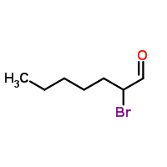 ___________________________

  - 4-ethyl-3-methyloctanal ___________________________

  - 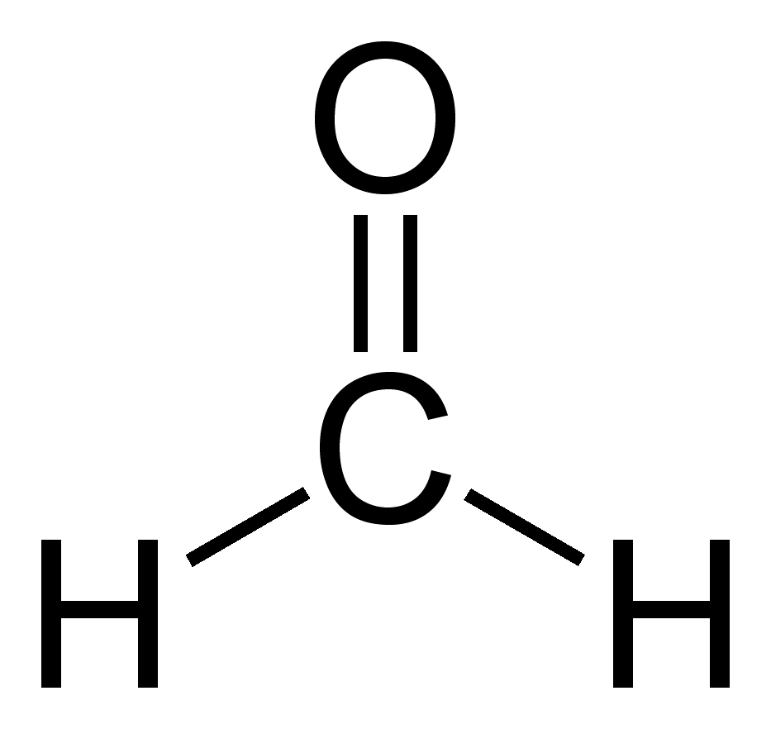 __________________________

- Name or draw the following molecules.
  - 3,3-dimethyl-2-hexanone ________________________
  - CH₃CH₂(CO)CHClCH₃ ________________________
  - 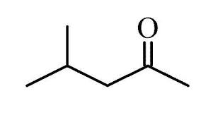 __________________________
  - CH₃CH=CHCH₂CH(CO)CH₂CH₃ __________________________

- Draw and name some isomers with the formula C₅H₁₀O.

- Which of the following will not have the formula C₆H₁₂O?
  - 4-hexen-2-ol c. 3-methylhexanal
  - 2,3-methylcyclobutanol d. 2,4-dimethyl-3-pentanone
- Secondary alcohols will oxidize to
  - Aldehydes c. alkenes
  - Esters d. ketones
- Write the molecular formula for the following molecules:
  - Octanal ___________
  - 3-methyl-2-pentanone ___________

- Oxidize the following reactions. Draw and give the name.
[O]
  - 3-ethyl-1-octanol

[O]
  - 3-methyl-3-hexanol

[O]
  - 3-ethyl-2-octanol

- Reduce the following reactions. Draw and give the name.
Pt
  - Butanal + H₂
Pt
  - 2-pentanone + H₂

- What type of alcohol oxidizes to form aldehydes?

- What type of alcohol oxidizes to form ketones?

- Aldehydes reduce to _________________
- Ketones reduce to ____________________

