Part 1: Match the following. (*these terms are very important to know!)

- _______Molecules with the same formula, same bonding, but with a different spatial arrangement of atoms- not superimposable
- _______A molecule with at least one chiral carbon
- _______Molecules with the same formula but different bonding (atom attachment)
- _______A carbon with 4 different groups attached to it
- _______A carbon with 2 or more identical groups attached, or having only 2 or three bonds.
- Chiral carbon b. structural isomers c. stereoisomers d. chiral molecule e. achiral carbon

- Which of the following contains a chiral carbon?
  - 4-ethyloctane
  - 2,2-dimethylpropane
  - 3-methyl-3-hexene
- Stereoisomers are / are not superimposable upon each other.
Part 3: Carbohydrates
- For the following two carbohydrates, identify A) how many chiral carbons there are, B) what the overall chirality is and C) the generic name
  - b.
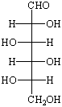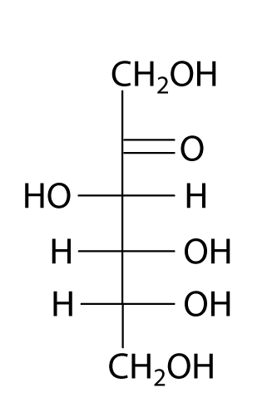
______________________ _____________________

- What is the C formula for carbohydrates? ____________________
- Which is more predominate in nature, D or L, and is thus sometimes omitted from the name? _______

REVIEW
I. Aldehyde/Ketone + alcohol hemiacetal
- 3-methylheptanal + 1-ethanol

- 3-hexanone + 1-ethanol

II. Hemiacetal + alcohol acetal
- Product from 1 + 1-ethanol

- Product from 2 + 1-ethanol

III. Put the following into a ring.
- 5-hydroxyhexanal 6. 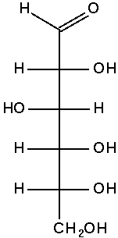

IV. Oxidize the following alcohols.
- 3-methyl-1-heptanol 8. 3-hexanol

V. Reduce the following aldehydes or ketones.
9. Pentanal 9. 3-pentanone

